**Write Out Loud:**

**A Multi-modal Way to Learn Chinese Characters and More**

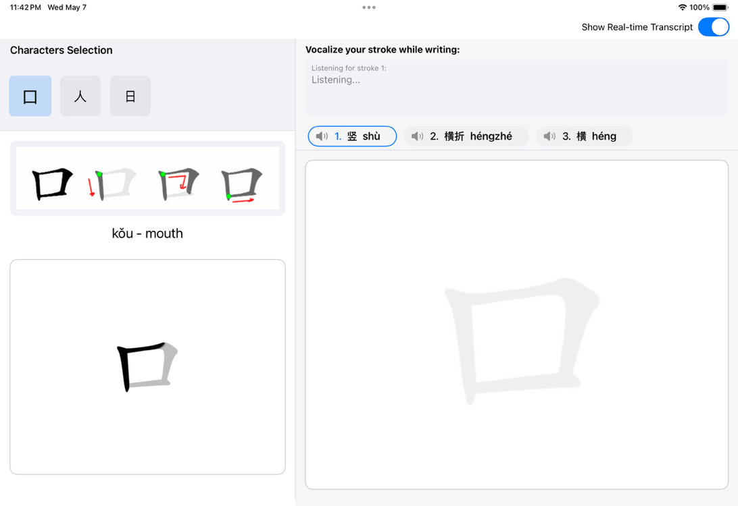

**Freya Tan**

**Junru Ren**

Addressing the inherent complexities of mastering Chinese characters—particularly accurate stroke order and precise visual-motor skills—"Write Out Loud" introduces a novel multimodal learning experience on iPadOS. Traditional methods often fall short in providing immediate, engaging, and sensorily rich feedback. Our system tackles this by uniquely integrating handwriting, speech, and visual guidance.

Leveraging the Apple Pencil for kinesthetic input and the built-in microphone for auditory input, "Write Out Loud" guides users to trace character strokes (e.g., for "口" or "人") while simultaneously vocalizing the specific name of each stroke (such as "héng" or "shù"). Upon character completion, the application delivers a holistic evaluation, assessing the accuracy of the user's drawn strokes against ideal paths, verifying the correctness of the vocalized stroke names, and analyzing the temporal synchronization between the writing and speaking actions. This active, concurrent engagement of multiple sensory pathways is designed to significantly strengthen stroke order memory and improve overall handwriting quality.